
Step-by-Step Guide: Biofeedback Therapy for Physical Trauma
This guide provides a structured approach to using biofeedback therapy for clients experiencing physical trauma—whether from recent injuries, surgeries, or chronic pain conditions.

1. Understanding the Layers of Trauma
Physical trauma may involve multiple layers of the body, such as:
✅ Skin (external damage, swelling, bruising)
✅ Muscles (strain, inflammation)
✅ Nerves (pain, shooting sensations, sensitivity)
✅ Cartilage (joint discomfort, prolonged stiffness)
✅ Bones (fractures, structural misalignment)

2. Initial Scan & Identification of Affected Areas
A. Locating the Trauma in Oberon Software
- Identify the location of the pain or trauma.
  - If it's the face, check head longitude cross-sections (left/right).
  - For swelling: Check skin of the upper lip, cheek area, and facial skin.
  - For lower back pain: Scan lumbar, pelvic area, and lumbosacral plexus.
- Scan within the affected area:
  - Skin (especially if there was surgery or an open wound).
  - Nerves within the skin and muscles.
  - Muscle tissue (to determine inflammation).
  - Cartilage (especially for joint pain).
- Focus on Key Indicators:
  - Energy Levels: Lower values indicate dysfunction.
  - KOD (Coefficient of Optimal Dispersion): Lower values show areas that need therapy.
  - Shape Analysis: Look for inflammation or degeneration patterns.

3. Providing Immediate Pain & Inflammation Relief
A. Using Allopathy for Pain Management
- Go to Analysis Page → Select Allopathy
- Search & Apply:
  - Painkiller (first line of relief).
  - Anti-inflammatory (reducing swelling).
  - Nerve Pain Remedies (for shooting pain, pinched nerves).
- Adjust Auto Model Settings
  - Click "Adjust All Auto Model" to let Oberon select the most relevant remedies.
- Use a High Draw Count in Reprinter:
  - Mild pain: Start at 2,000+ RF.
  - Severe pain: Increase to 5,000-15,000 RF.
  - Chronic issues: Consider wearable item or tincture.

4. Layering Therapy for Effective Healing
A. Step-by-Step Therapy Plan
Step | Therapy Focus | Actions in Oberon
1. Pain & Swelling Relief | Nerve & Skin Analysis | Use Allopathy for painkillers, anti-inflammatory, nerve pain relief.
2. Infection Prevention | Bacterial/Fungal Scan | Add “ANT” Topics – keyword search for remedies: Bacteria, Mold, Fungus, Virus, and Helminth (Add only the lowest dispersion remedies)
3. Deep Tissue Healing | Muscles, Cartilage, and Bone Healing | Scan and apply remedies for muscles, nerves, and joints.
4. Hydration Support | Cellular Hydration & Organ Function | Look for Hemoglobin & Hydration markers.
5. Constipation & Organ Support (if needed) | Gallbladder, Digestive Tract, Liver | Run remedies for gut motility, hydration, and enzyme support (Key word search hydration and constipation)

5. Finalizing the Therapy & Recommendations
A. Completing the Reprinter Therapy
- Run therapy 2-3 times per day for acute pain relief.
- Use wearable items, wax, loctions or tinctures for longer-lasting effects.
- IMPORTANT TIP: RF remedy preparation holds the strongest potency for a remedy. If the client is in severe pain you may have to continue RF therapy even if you created the remedy using another modality (ie. Wax, lotion, cream, wearable item, or tincture).
  - RF remedy should be every 3-4 hours until the client states they do not have any discomfort.
B. Delaying Metatherapy
- DO NOT run Metatherapy immediately after remedy preparation.
- Wait 4+ hours before introducing Metatherapy for long-term repair.
- Metatherapy should be used after initial pain relief has been achieved.

6. Special Considerations for Chronic & Post-Surgical Patients
For long-term nerve pain: Focus on nervous system therapies & energy balance.
For post-surgery recovery: Prioritize skin healing, pain relief, and hydration.
For chronic pain patients: Offer layered therapy over multiple sessions.
If constipation is an issue: Check hydration, gallbladder, and gut motility.

7. Case Study Example: Treating Facial Swelling & Nerve Pain
Scenario: A patient presents with swelling on the right cheek, nose, and upper lip.
Step-by-Step Treatment Plan:
🔹 Scan Head Longitude (Right Side)
🔹 Scan Skin of Upper Lip & Cheek
🔹 Scan Facial Nerve (Right Side)
🔹 Apply Painkiller & Anti-inflammatory Remedies
🔹 Use Hydration & Nerve Pain Support
🔹 Delay Metatherapy for at least 4 hours

Live Case Study Summary:
A male client presented with a left ankle sprain. The goal was to identify the source of trauma and imprint a pain relief remedy using the reprinter cup and paraffin output.

STEP 1: Initial Scan
- Scan the Affected Area:
  - Start with all areas of the left foot and include the ligaments.
    - Foot Transverse Section
    - Foot Cut
    - Joint Foot
    - Articular Ligaments
- Navigate the Thumbs (Left Side of Research Page):
  - Within the foot, select and scan the muscle.
  - Within the muscle, scan the nerve bundle.
  - Return to the ligaments of the foot, and scan:
After you complete a scan of the organ – click on the thum to complete a scan of the thumb.
    - Osseous tissue (bone)
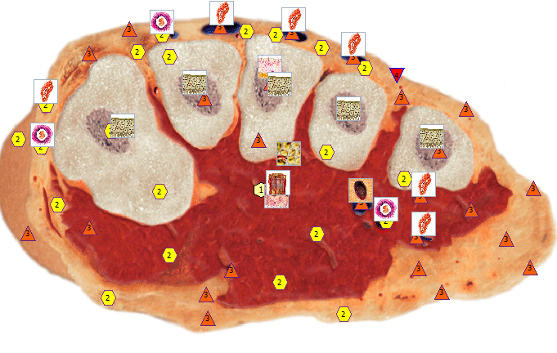
    - Hyaline cartilage
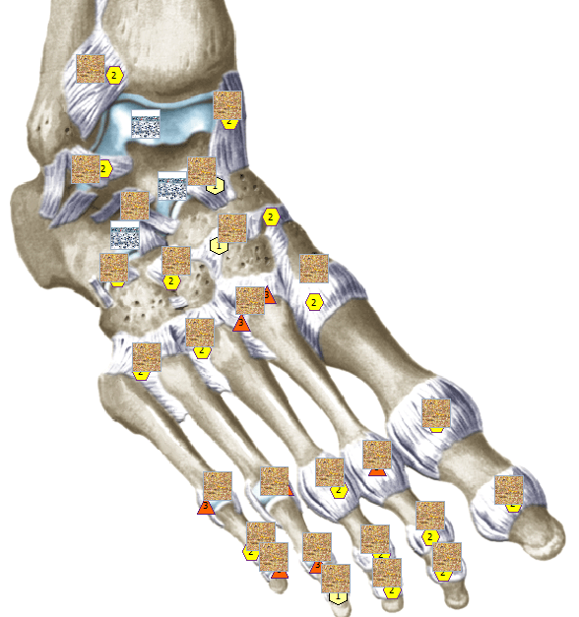

STEP 2: Evaluate Findings
- Review the following for each scanned structure:
  - KOD (Coefficient of Distribution)
  - Energy
  - Shape
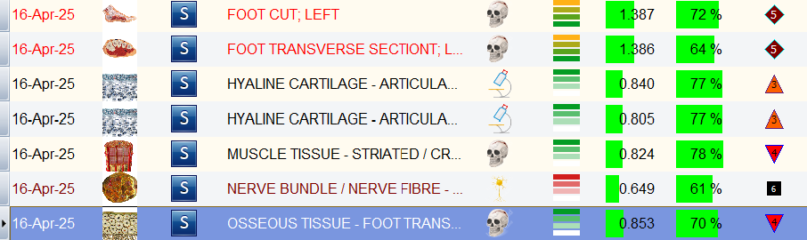
TIP: Prioritize the structure with the lowest KOD and Energy for remedy preparation. In this case, the nerve bundle had the lowest KOD and Energy.

STEP 3: Prepare the Remedy for Nerve Bundle
- Go to the Analysis Page for the Nerve Bundle.
- Select the Allopathy (Painkiller) topic.
- Click Show All → highlight a remedy → click Adjust All → then Auto Model.
- Add Additional Targeted Remedies:
  - Manually add the Allopathy topic again.
  - In the search bar, type "nerve pain".
  - Review the Etalon Descriptions and manually select 1–2 targeted remedies for nerve-related pain.
- Go to Reprinter:
  - Choose Paraffin as the output.
  - Set Draw Count:
    - Sensitive clients: Start at 500
    - Moderate pain: 2,000–6,000
    - Severe/urgent relief: 8,000–15,000
    - Extreme cases: Up to 25,000
WARNING: High Draw Count Always begin with the lowest appropriate draw count. Check in with the client to assess symptom relief before increasing. High-frequency imprinting (above 10,000) may cause discomfort or overstimulation in some individuals.
- Click Start Preparation to imprint the remedy into your chosen medium (e.g., tincture, cream, or wearable).

STEP 4: Repeat for Muscle Discomfort
- Return to Research Page → select the muscle of the foot.
- Go to Analysis Page.
- Repeat the Allopathy (Painkiller) process:
  - Show All → Adjust All → Auto Model.
- Add Additional Remedies:
  - Manually add Allopathy topic.
  - Search keyword: "pain".
  - Use Etalon Description to identify remedies specific to muscle pain/discomfort.
  - Select and send to Reprinter using the same paraffin process.

Output Options & Recommendations
- Mediums:
  - Cream or lotion (e.g., natural pain-relieving base cream)
  - Tincture (50/50 alcohol and water)
  - Wearable item (e.g., metal bracelet)
- Application:
  - Apply topically over injury.
  - Use wearable daily for continuous frequency exposure.
  - Reassess symptoms every 3-4 hours for the first day to see if discomfort is at a manageable state.
REMEMBER – RF remedies are the most potent and may be necessary for clients experiencing severe pain. When working with a client, offering remote RF therapy as part of their healing plan can help effectively reduce symptoms. For best results, be sure to layer both pain-relief and anti-inflammatory remedies across all sections of the affected area. This approach can be applied to any part of the body with a recent or past injury. Reducing inflammation will help the body respond more effectively to metatherapy and other forms of treatment.
Additional Topics for Joint and Fracture Repair:
Remedy Name | Category / Topic | Primary Function | Indications / Notes
Osteoporosis (INV) | (INV) Pathology | Indicates decreased bone density; used for identifying trauma progression | Can be local (trauma, fractures) or general (aging, toxins, corticosteroid use)
Minamin – Coral Club | Phyto-Corrector | Bone & tissue repair, alkalizes pH, improves nutrient absorption | Fractures, sprains, skin conditions, headaches, digestive issues, sinusitis
Skin Line (Art of Life) | Phyto-Corrector | Anti-allergic, vascular support, mild anti-inflammatory | Allergies, asthma, neurodermatitis, food allergies
Sulphur – MSM with Microhydrin | Phyto-Corrector | Reduces inflammation, provides sulfur for repair | Arthritis, cystitis, eczema, dermatitis, colon cancer support
White Oak Bark | Herbal Remedy | Mild astringent and anti-inflammatory properties | Traditionally used for wound healing
Eupatorium Perfoliatum | Homeopathy | Pain relief from fever, fractures, influenza | Bone pain, periodic fever
Symphytum | Homeopathy | Bone fracture pain relief, bone regeneration | Fractures, phantom limb pain, periosteal pain
Aires +2 | Nutricevtics and Parapharmaceuticals | Reduces pain, inflammation, speeds bone healing | Fractures, injuries
Biogevity | Nutricevtics and Parapharmaceuticals | Hormonal & cellular regeneration, bone renewal | Osteoporosis, chronic fatigue, poor healing, memory loss
Biozyme – Vitaline | Nutricevtics and Parapharmaceuticals | Enzymatic anti-inflammatory and circulatory support | Arthritis, fractures, bruises, post-op recovery, inflammation
Calcimid – Optima | Nutricevtics and Parapharmaceuticals | Calcium replenishment, fracture healing, immunity support | Osteoporosis, infections, menopause, allergic reactions
Calcimax – Artlife | Nutricevtics and Parapharmaceuticals | Bone & joint support | Systemic osteoporosis, dental health, skin conditions, diabetes
Gel for Joints – Planet M | Nutricevtics and Parapharmaceuticals | Pain & inflammation relief, joint regeneration | Sprains, joint trauma, sports injuries
MSM with Microhydrin | Nutricevtics and Parapharmaceuticals | Sulfur support for tissue repair | Same as MSM above
Planet M – Alexandrine | Nutricevtics and Parapharmaceuticals | Multi-functional body support | Joint disease, hair & skin health, immune & nervous system support
Quercetin – Joy | Nutricevtics and Parapharmaceuticals | Anti-allergic, antioxidant | General wellness
Ravsin – Dr. Nona | Nutricevtics and Parapharmaceuticals | Anti-inflammatory, metabolism support, tissue repair | Skin issues, arthritis, trauma recovery, liver detox, hormone balance
Silimin – SiF | Nutricevtics and Parapharmaceuticals | Osteosynthesis stimulant, calcium balance regulator | Fractures, joint sprains, dental and hair health
Coral | Stone Therapy | Mineralization, circulation booster, joint strength | Metabolism, bone healing, cardiovascular support
Serpentine | Stone Therapy | Pain relief, supports bone healing | Used historically for fractures, pain, lethargy
Bonviva (Allopathy) | Allopathy | Osteoprotective, bone resorption inhibitor | Postmenopausal osteoporosis, fracture prevention
Botox (Allopathy) | Allopathy | Neuro-muscular relaxant | Muscle spasms, facial pain, trauma relief
Donalgin (Allopathy) | Allopathy | Analgesic and anti-inflammatory | Fractures, arthritis, soft tissue trauma, dental/gyn issues
Osteogenon (Allopathy) | Allopathy | Bone formation stimulator, calcium/phosphate balancer | Osteoporosis, fractures, dental delay, post-pregnancy, hormone-related bone loss
Tycveolum (Allopathy) | Allopathy | Anti-inflammatory, regenerative for skin and soft tissues | Prostate, digestive, liver issues, also used topically on wounds and trauma
Quercetin Plus with Bromelain | Nutripower – Nutraceutical | Anti-inflammatory, antioxidant, vascular support | Muscle & joint support, allergies, circulation

Meta Therapy Protocol for Physical Trauma Recovery
Purpose:
To promote long-term healing and regeneration through regular Meta Therapy sessions targeting the osteoskeletal, nervous, and digestive systems — all of which are commonly impacted in acute injuries such as sprains, strains, or fractures.

Meta Therapy Schedule Guidelines:
Client Type | Frequency | Intensity (BY)
Sensitive clients | 4–5 days per week | BY 10
Tolerant clients | 4–5 days per week | BY 20
Severe injuries | 2 sessions per day | BY 10–20
Important Note: Start gently for new clients or clients new to Meta Therapy. Always monitor symptoms and adapt accordingly. Consistency is key for regenerative effects.

Target Systems & Justification:
System | Reason for Targeting
Osteo | Bone and joint integrity, tissue recovery
Nervous | Pain regulation, nerve repair, coordination
Digestive | Supports nutrient absorption for tissue healing

Note: completing a full body scan and creating a report will help to create a strong meta therapy plan even after an injury. Refer to Oberon’s training page for videos on how to complete this process.

Disclaimer
The information provided in this training document by Enter Balancing Rays is intended for educational and informational purposes only. It is not a substitute for professional medical advice, diagnosis, or treatment. The methods, protocols, and recommendations discussed are based on biofeedback and holistic approaches, and results may vary depending on individual circumstances.
The tools and techniques described, including but not limited to biofeedback and frequency-based remedies, are complementary methods and should be used alongside conventional medical care, not as a replacement. Enter Balancing Rays does not claim to diagnose, cure, or prevent any disease or condition.
By participating in this training or implementing the recommendations provided, you agree to assume full responsibility for your actions and outcomes. Enter Balancing Rays and its representatives are not liable for any direct, indirect, or consequential damages resulting from the use of the information presented.
For any questions or concerns, please contact Enter Balancing Rays at Kimberly.s@enter-balancing-rays.com or call 352-932-5928.

