Pain TOPIC:
“Allopathy (Painkillers) used on Hemoglobin in Oberon (Spelled HAEMOGLOBIN)
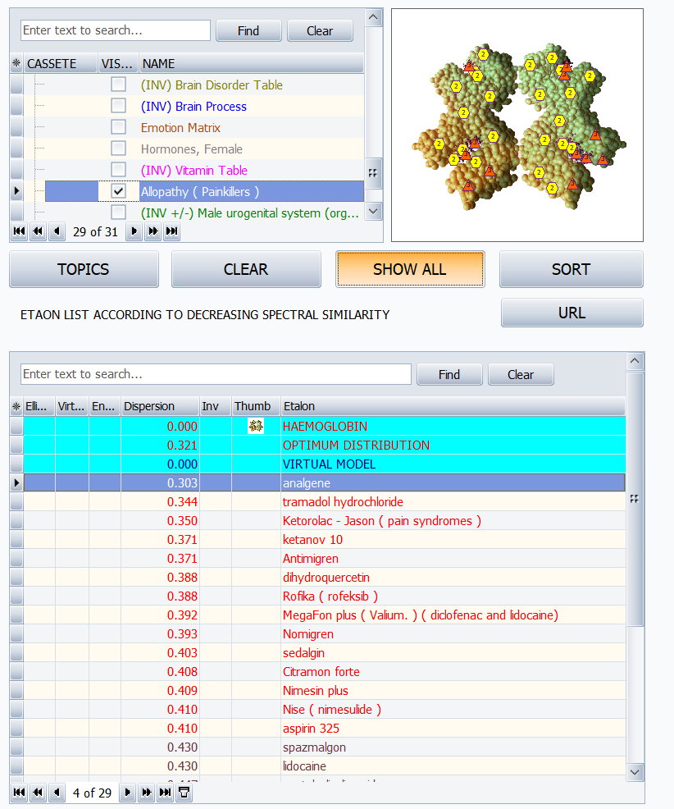

Pain suggestions for Cancer:
Red light panels are powerful for stimulating mitochondria and helping pain and inflammation naturally.

Regarding PH solution: Mix
1qt distilled water
+ 1 tsp celtic salt(if BP is not high)
+ 1 tsp baking soda

Make a solution then divide in 4 parts.
Drink 1/4 of the solution every 2 hours.

Additional suggestions:
- Banerji protocols
- B17 vitamin
- Exercise while breathing oxygen
- Fast and stop eating anything that has sugar of that produces sugar in the body, like potatoes
- fenbendazole (research these brands: fenben or panacur C)
- High dose vitamin C infusion
- UVT : Mycelcaps Supplements - AHCC (active substance)
UVT : https://www.finclub.ro/fin-mycelcaps-new/
- Dr. Emmanuel Revici, MD, described two patterns of pain in cancer cases, connected to either an acid imbalance or an alkaline imbalance at the cellular level. Acid imbalances will have pain aggravated in the morning and early afternoon and alkaline imbalances will have pain aggravated in the late afternoon and evening. You can find more information in the book titled "The Doctor Who Cures Cancer", by William Kelley Eidem
- Acid pain patterns will be relieved with unsaturated fatty acids (unsaturated fats) and alkaline pain pattern will be relieved with sterols lipids (saturated fats)
- Healnavigator.com
- Drleemerrit.com
the medical rebel are websites you will find protocol for fenbendazole. Very detailed explanation on how to proceed plus others will communicate on what has been working for them.

Venom conversation suggestions:
- Proteolytic enzymes such as pancreatin, rutin, trypsin, chymotrypsin, bromelain, and papain along with quercetin help to break down the micro-clotting that may be caused by the snake venoms.
- Natto kinase, bromolyn, cur cumin help to break down v

