Zoe Genetic Disorder Additional Thoughts:
The video goes over a general and “to the point” analysis which already does a great job of listing problems that Zoe presents with. Here are some screenshots of more specific findings.
- Chromosome 19 This is the chromosome associated with this genetic disorder
In addition to that, I looked the 19th chromosome. According to the limited online research I did, there was indication that the 19th chromosome is the problem in this genetic disorder:
Chromosome 19 in Oberon has low energy (level 5)
- Neurodevelopment disorder
Oberon in “White Substance” along with DNA component in video showed this pathology
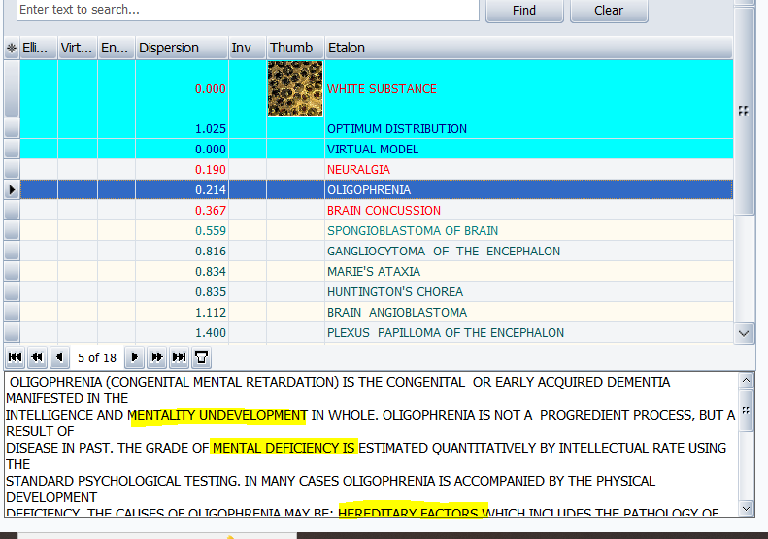
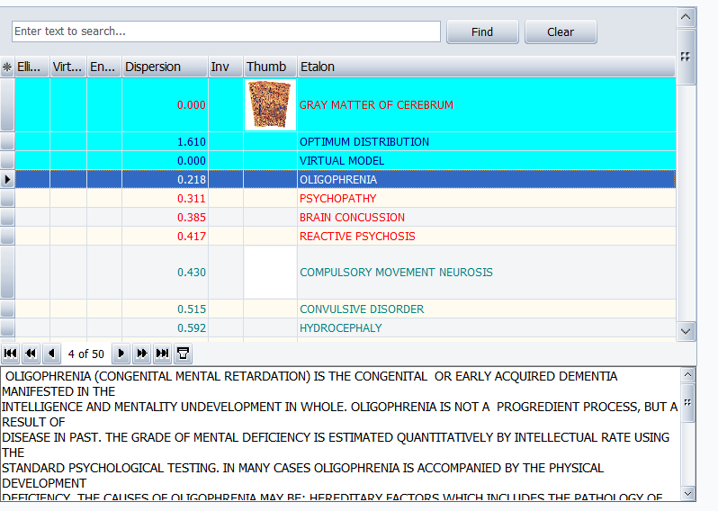
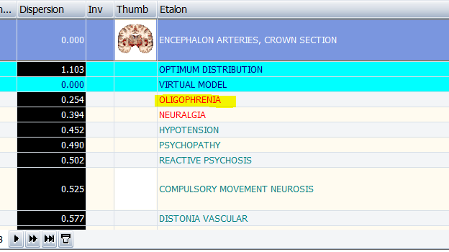

- Psychiatric risk gene
Oberon picked this up in cranial nerves
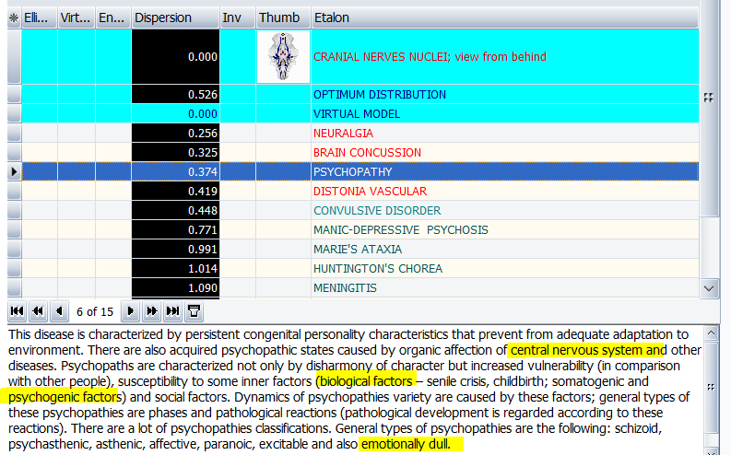
- Muscle tone (Hypotonia) Scan of 19th chromosome in Oberon
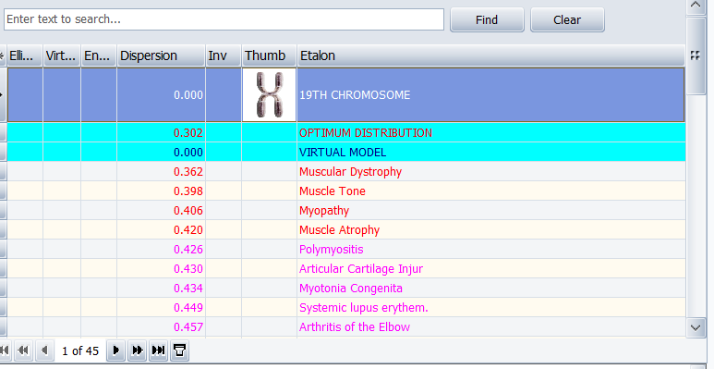
- Seizures
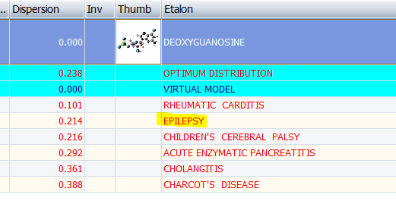
- Macrocephaly
